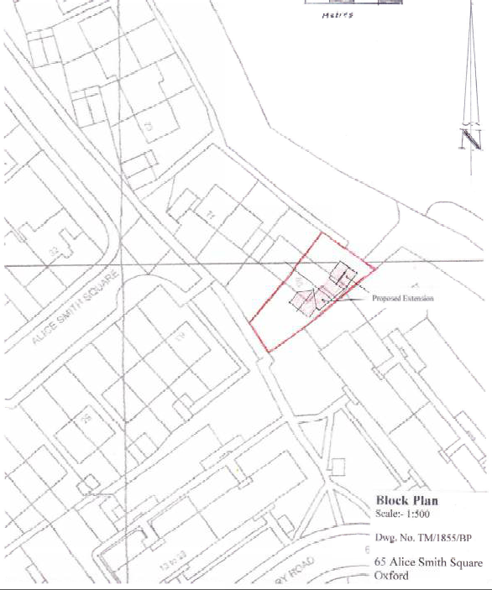

**Appendix 1**

19/02106/FUL – 65 Alice Smith Square

Proposed block plan